AI-Lingo
State Diagram & Class Diagram
System Analysis & Design – Data Flow & System Behavior

4. State Diagram

4.1 Purpose and Scope
A state diagram shows the states an object passes through during its life and the events that cause it to move from one state to another. It complements the Sequence and Activity diagrams: those describe how components interact and how a process flows, while the state diagram describes how the status of a single object changes over time.
Four objects with a meaningful life cycle were selected. Each one has a status field in the Database Design (Firestore and Hive structures) and is driven by the use cases defined in the System Analysis section.
Object | Status values (source) | Use cases | Functional requirements
Saved word (UserWord) | new, learning, learned  (UserWord.status) | UC-06 | FR-08, FR-09
Lesson | generated, in_progress, completed  (Lesson.status) | UC-04, UC-05 | FR-05, FR-06, FR-07
Level assessment | in_progress, completed  (LevelAssessment.status) | UC-02 | FR-03
Sync operation | pending, syncing  (life cycle of a SyncOperation in Hive syncQueueBox) | UC-09 | FR-10, FR-11, FR-12

Notation and colour key
Element | Meaning
Filled black circle | Initial state: where the life of the object begins.
Circle with an outer ring | Final state: the object is completed or removed.
Rounded rectangle | A state. The lower compartment lists entry actions executed when the state is entered.
Arrow label | event [guard] / action – the event that triggers the transition, an optional condition, and the action performed.
Dashed outline region | A composite state: a group of states that share a transition (for example, deleting a saved word from any of its states).
Colours | Blue: start state and normal transition. Orange: active state and repeated (self) transition. Green: successful completion. Red arrow: regression, failure or removal. Purple dashed arrow: alternative entry.

4.2 State Diagram – Saved Word
A word becomes a UserWord when the learner saves it (UC-06). It starts as new, becomes learning after the first review, and is marked learned once the learner has answered correctly N times. An incorrect answer sends a learned word back to learning. Deleting the word, or the whole account, can happen from any of the three states, so it is drawn from the enclosing composite state.
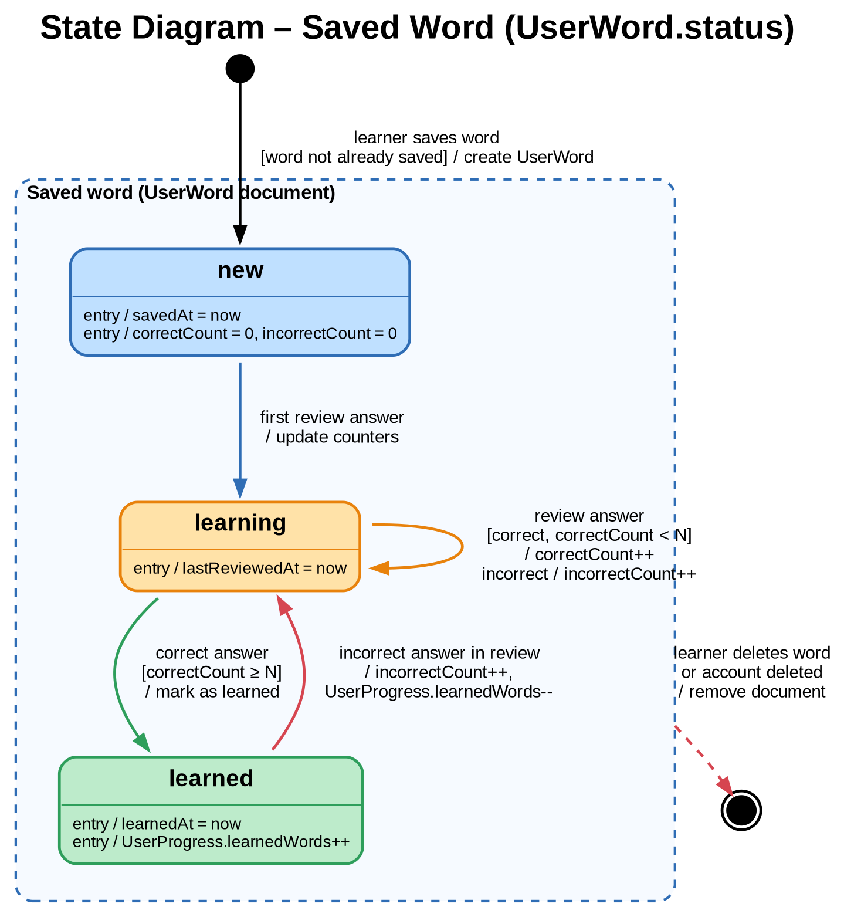
Figure 1: State diagram of a saved word (UserWord.status)
# | From | Event | Guard | Action | To
1 | Initial | Learner saves a word | Word is not already saved | Create UserWord; savedAt = now; counters = 0 | new
2 | new | First review answer | – | Update correctCount or incorrectCount; lastReviewedAt = now | learning
3 | learning | Review answer | Correct and correctCount < N, or incorrect | correctCount++ or incorrectCount++ | learning
4 | learning | Correct review answer | correctCount ≥ N | learnedAt = now; UserProgress.learnedWords++ | learned
5 | learned | Incorrect answer in review | – | incorrectCount++; UserProgress.learnedWords-- | learning
6 | Any saved state | Learner deletes the word, or the account is deleted | – | Remove the vocabulary document and its local copy | Final
Note: N is the number of correct answers required to mark a word as learned. It is a project decision and should be defined as a single constant shared by the Vocabulary ViewModel and the Database Design.

4.3 State Diagram – Lesson
A lesson is one AI-generated conversation session for a learner and a scenario (UC-04). It is created in the generated state, moves to in_progress when the learner submits the first response, stays there while the practice continues (UC-05), and becomes completed when the learner finishes and the AI evaluation is stored. Completed lessons remain as conversation history.
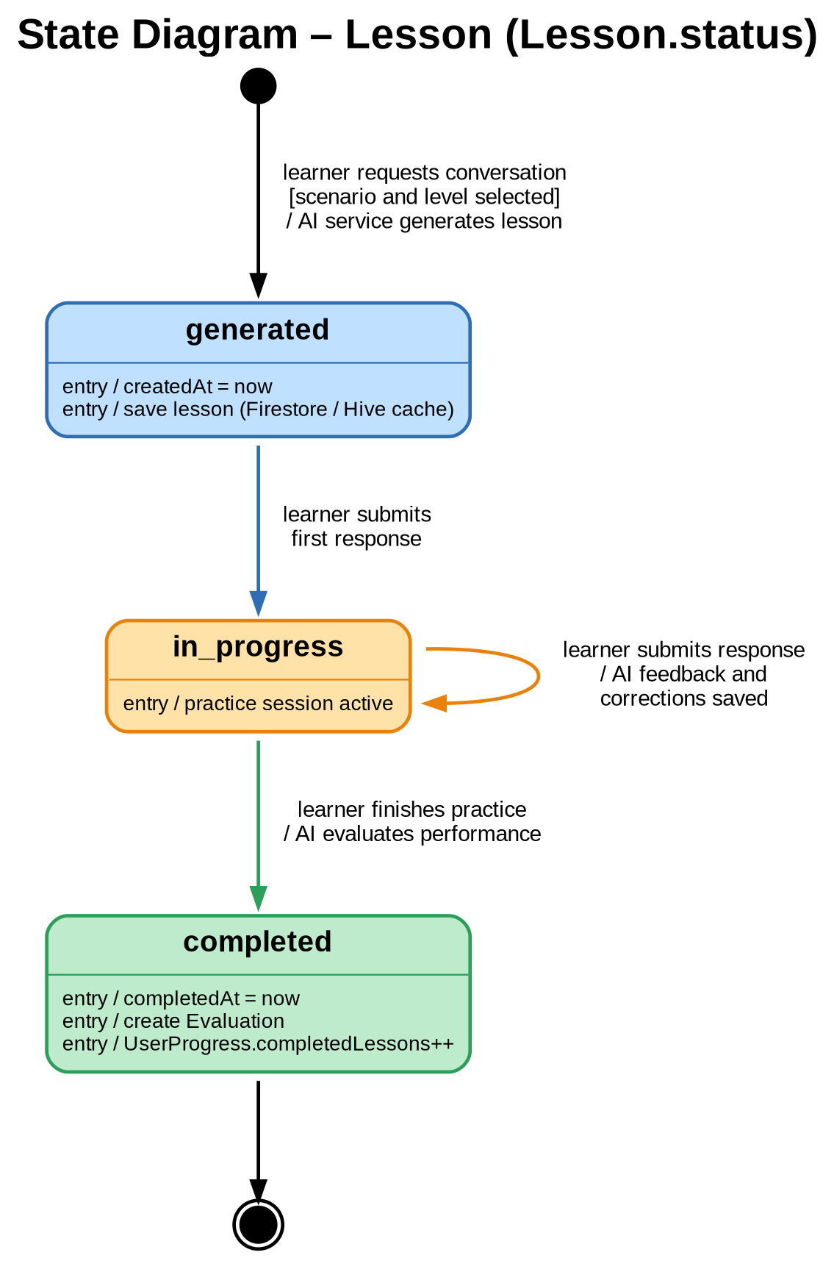
Figure 2: State diagram of a lesson (Lesson.status)
# | From | Event | Guard | Action | To
1 | Initial | Learner requests a new conversation | Scenario and level are selected | AI service generates the lesson; save it (Firestore, optional Hive cache); createdAt = now | generated
2 | generated | Learner submits the first response | – | Store the message; AI feedback; create Correction records for detected mistakes | in_progress
3 | in_progress | Learner submits another response | – | Store the message and corrections | in_progress
4 | in_progress | Learner finishes the practice | – | AI evaluates; create Evaluation; completedAt = now; UserProgress.completedLessons++ | completed
5 | completed | – | – | Lesson is kept as conversation history | Final
Error handling: if the AI service fails during transitions 1, 2, 3 or 4, the lesson stays in its current state, an error message is displayed, and the learner can retry (alternative flows of UC-04 and UC-05).

4.4 State Diagram – Level Assessment
A level assessment records how the learner's English level was determined (UC-02). A placement test takes time, so the record starts in in_progress and may be resumed later. A level that is chosen manually, or updated automatically from the learner's performance, is stored directly as completed.
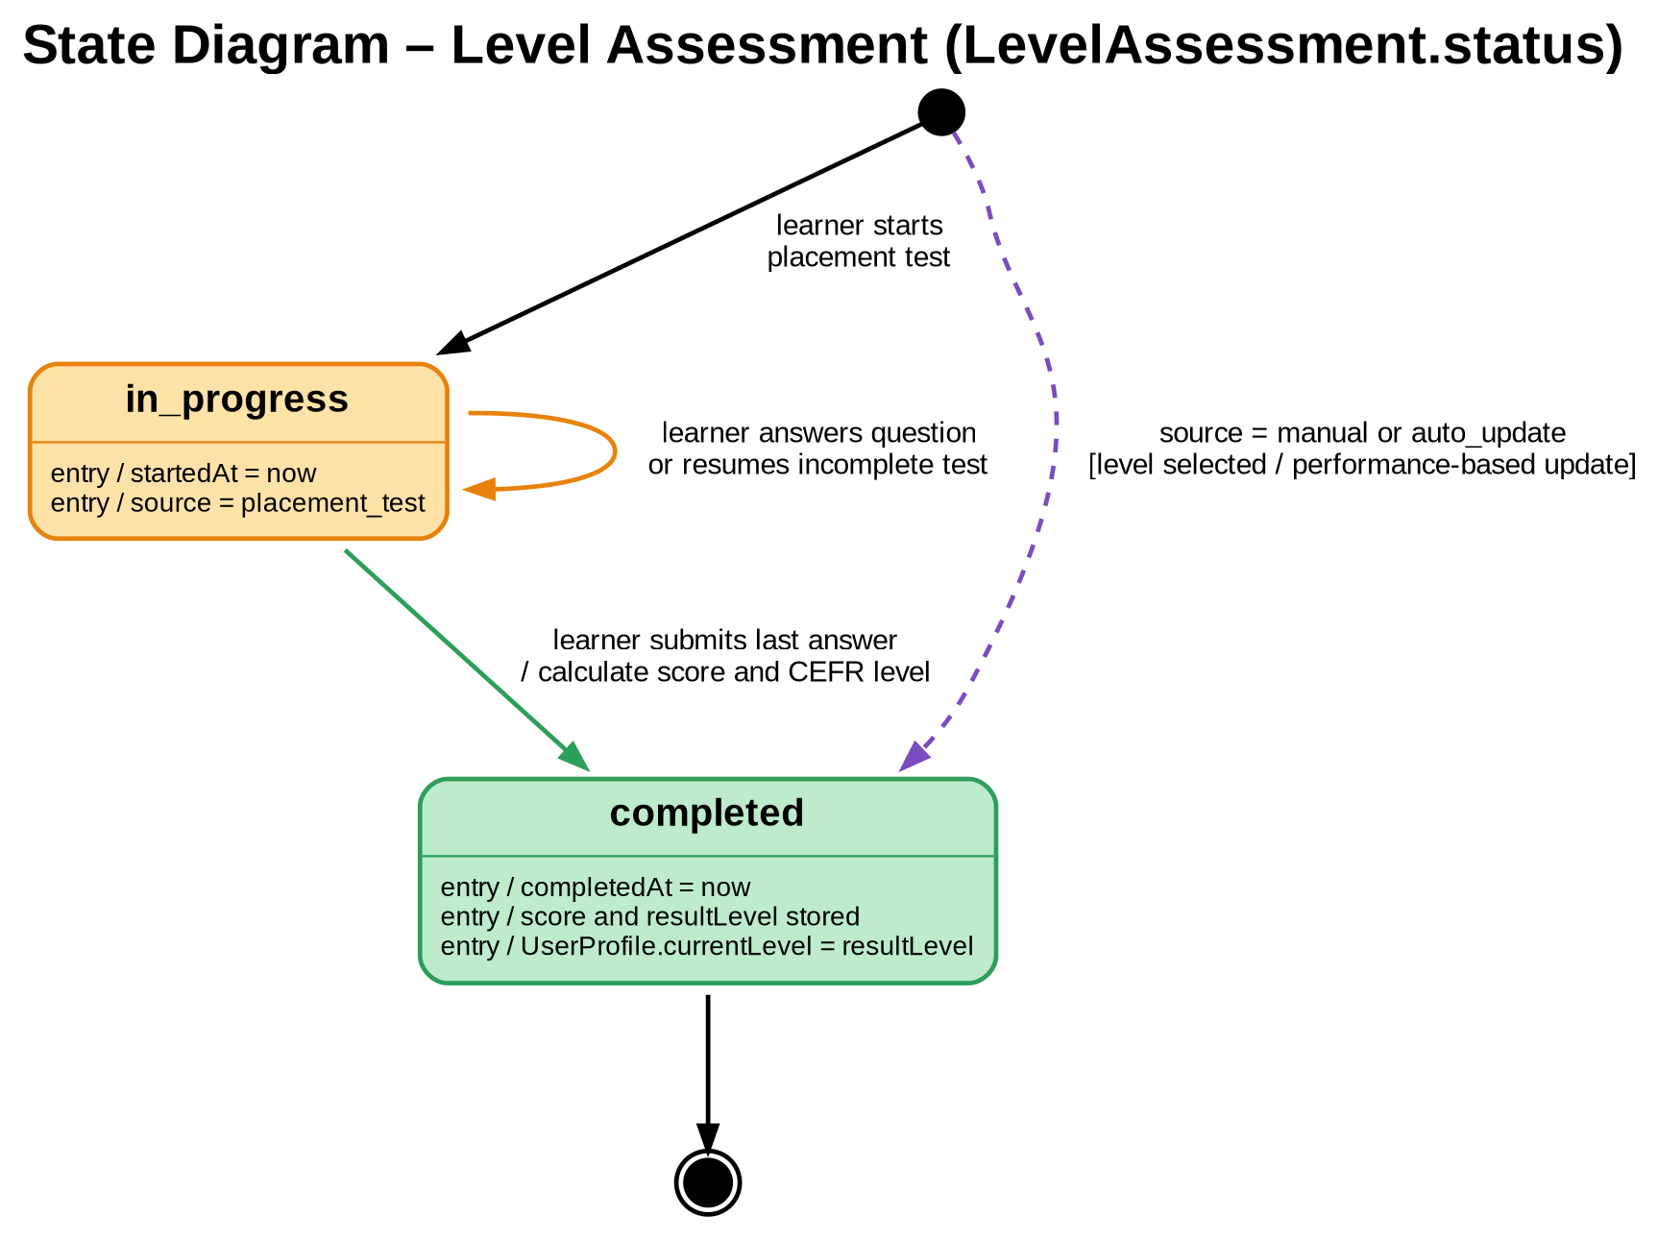
Figure 3: State diagram of a level assessment (LevelAssessment.status)
# | From | Event | Guard | Action | To
1 | Initial | Learner starts the placement test | – | Create LevelAssessment; source = placement_test; startedAt = now | in_progress
2 | in_progress | Learner answers a question or returns to an unfinished test | Test is incomplete | Save the answer; ask the learner to complete the assessment | in_progress
3 | in_progress | Learner submits the last answer | All questions answered | Calculate score and CEFR level; completedAt = now; UserProfile.currentLevel = resultLevel | completed
4 | Initial | Learner selects a level, or the system updates the level from performance | source = manual or auto_update | Create a completed record; update UserProfile.currentLevel | completed
5 | completed | – | – | Record is kept as level history | Final

4.5 State Diagram – Sync Operation
Data changed while the device is offline, or when cloud synchronization is not available, is stored locally and queued as a SyncOperation in the Hive syncQueueBox (UC-09). The operation stays pending until connectivity returns, is sent to Cloud Firestore while syncing, and is removed from the queue when the write succeeds. A failed write returns it to pending and increases retryCount, so no learner data is lost.
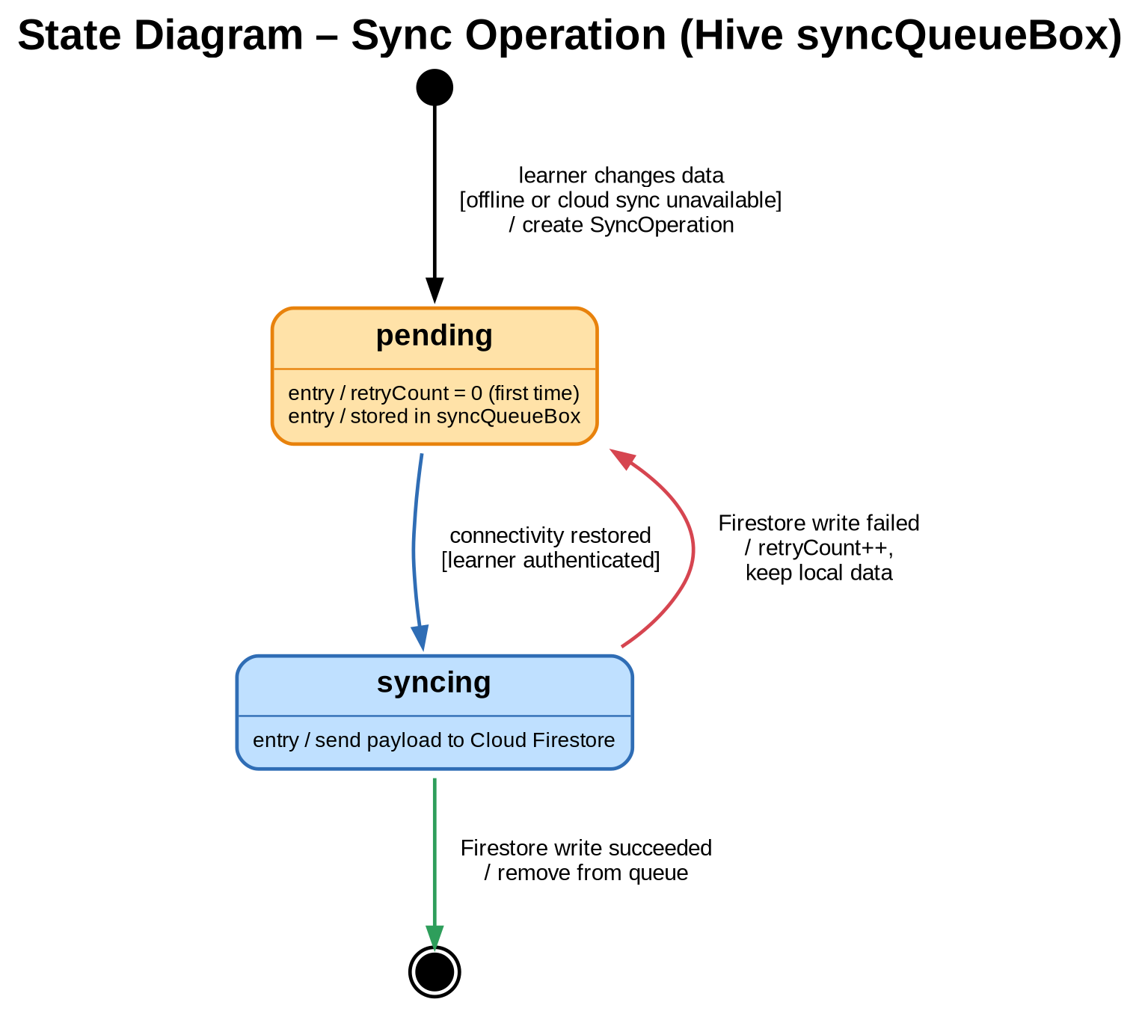
Figure 4: State diagram of a sync operation (Hive syncQueueBox)
# | From | Event | Guard | Action | To
1 | Initial | Learner changes data (save word, update progress) | Device is offline, or cloud sync is unavailable | Create SyncOperation (retryCount = 0) in syncQueueBox; keep the data locally | pending
2 | pending | Connectivity restored | Learner is authenticated | Send the payload to Cloud Firestore | syncing
3 | syncing | Firestore write succeeded | – | Remove the operation from the queue; update lastSyncAt | Final
4 | syncing | Firestore write failed | – | retryCount++; keep local data; try again later | pending
Note: the schema stores a SyncOperation with an operation type and a retryCount but no status field, so pending and syncing describe the life cycle of the queue entry rather than a stored attribute.

5. Class Diagram

5.1 Overview
The class diagram shows the static structure of AI-Lingo: its classes, their attributes and methods, and the relationships between them. It is built from two sources that were already defined in this document:
- Domain model – derived from the logical schema and ER diagram (Database Design). Each entity becomes a class, relationship cardinalities become multiplicities, and attribute names follow the Firestore field names (camelCase).
- Application classes – derived from the MVVM architecture (Software Architecture). The View, ViewModel and Model layers are expanded into screens, ViewModels, repositories and services, matching the processes P1–P6 of the Data Flow Diagram and the sequence diagrams.
To keep every diagram readable, the structure is presented in several figures. Names are identical across all figures and across the ER, DFD and sequence diagrams.

Notation key
Element | Meaning
+ / - | Public member / private member. Attributes are private; methods are public.
Type? | Nullable attribute (for example, completedAt is null until the lesson is completed).
Solid line with multiplicity | Association between two classes, for example 1 and 0..* (one to many).
Line with filled diamond | Composition: the part cannot exist without the whole (for example, a Message belongs to one Lesson).
Line with hollow diamond | Aggregation: the whole holds a collection of parts.
Dashed arrow | Dependency: one class uses another.
<<association class>> | A class that carries attributes of a many-to-many relationship (LessonWord, UserWord).
<<enumeration>> | A fixed set of allowed values.

Colour | Meaning
Blue | User module (domain figures); ViewModel layer (architecture figures).
Purple | Conversation module: categories, scenarios, lessons, messages.
Green | Vocabulary module: words, translations, saved words.
Orange | Assessment and feedback: level assessment, corrections, evaluation; also Hive models.
Rose / Teal / Amber / Grey | Architecture figures: View / Repository / Service / External systems.

5.2 Domain Model
The domain model is split into three figures by module. Classes that appear only as a reference in another figure are drawn with their name only.

5.2.1 User module
UserProfile holds the learner's profile, language settings and current CEFR level. Each learner has exactly one UserProgress summary (composition), any number of LevelAssessment records, and a list of interests selected from the shared Category list.
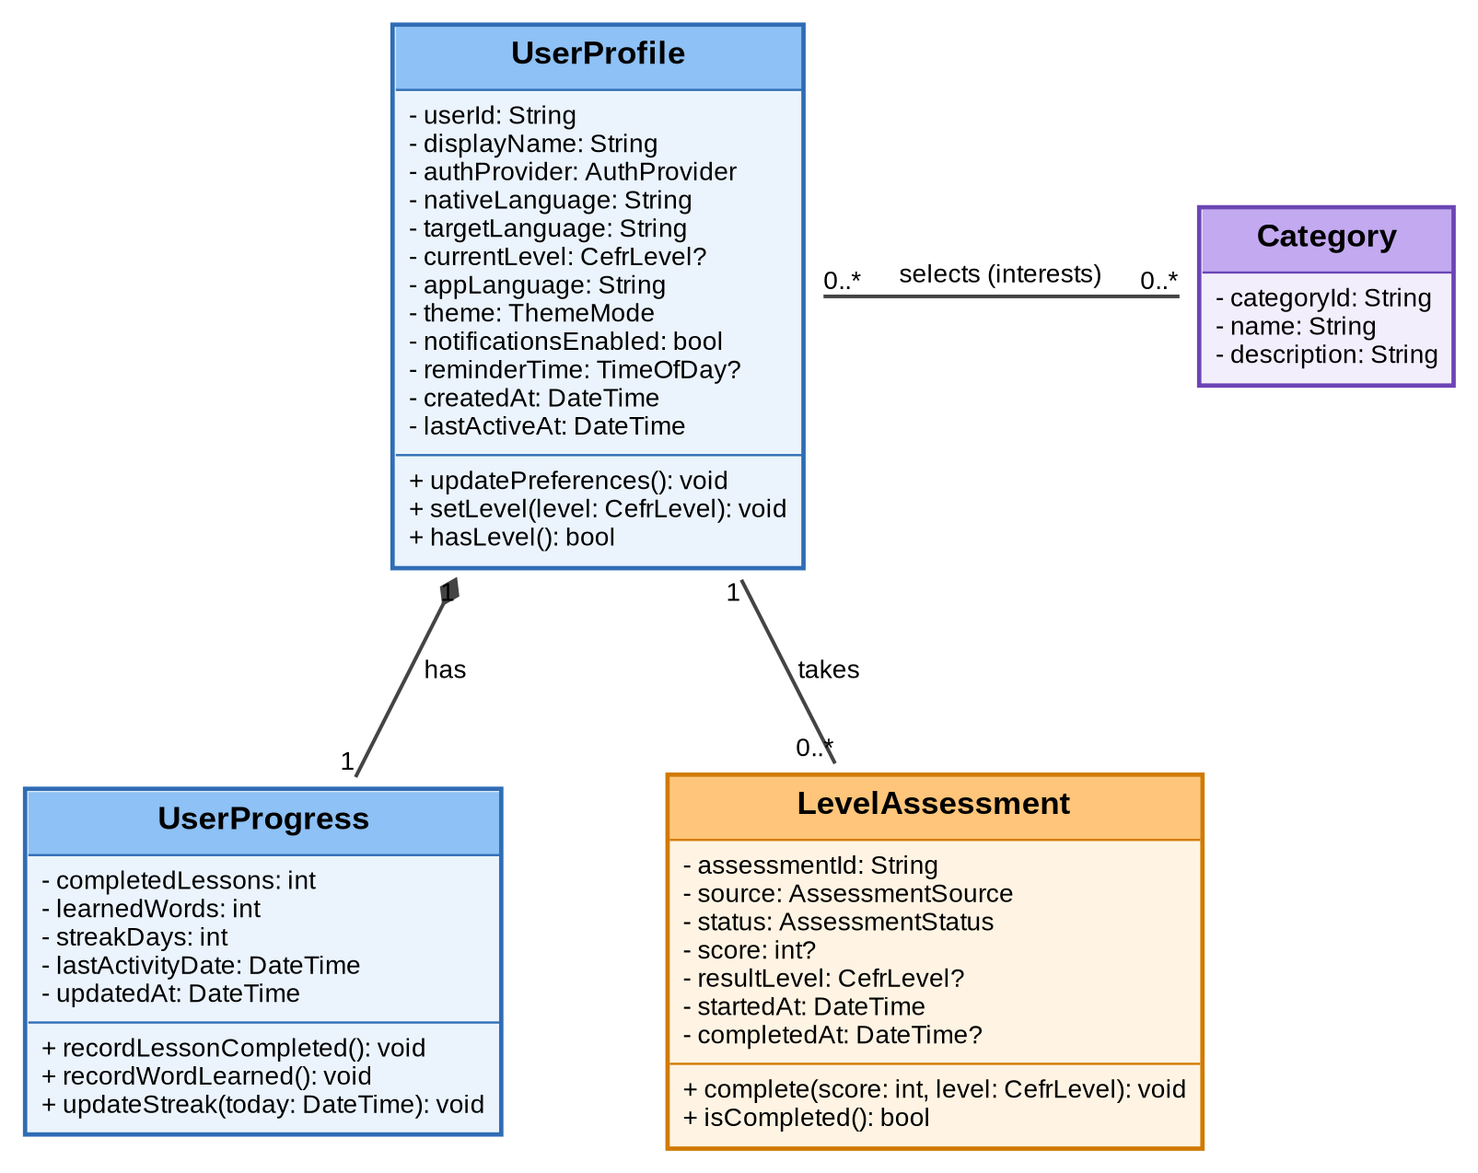
Figure 5: Class diagram – user module

5.2.2 Conversation module
A Scenario belongs to an optional Category and is either predefined (createdBy is empty) or created by a learner. A learner practises a scenario through a Lesson, which contains Messages and, once completed, one Evaluation. Corrections are attached to the learner's messages.
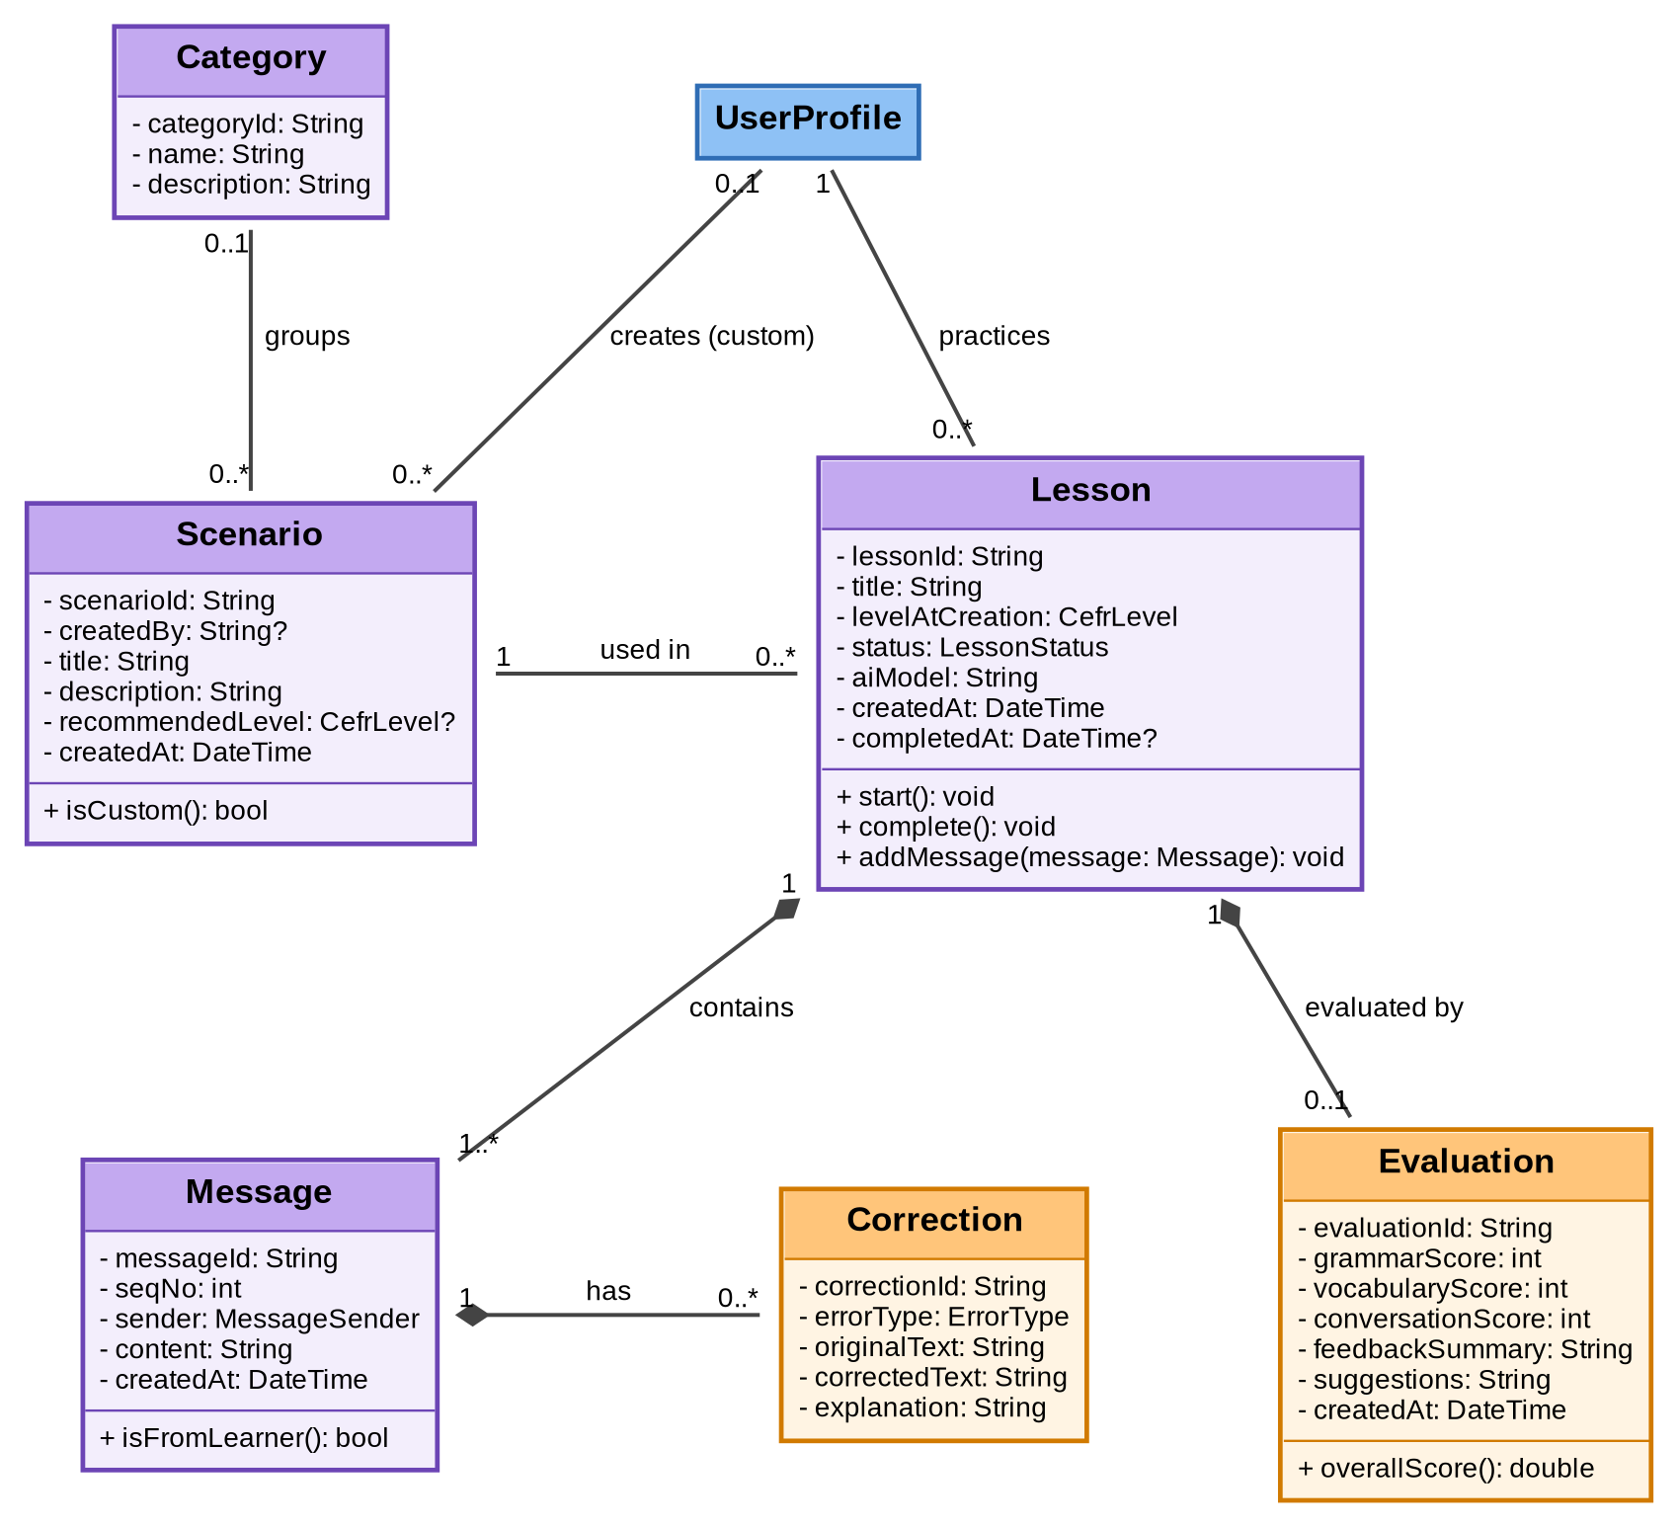
Figure 6: Class diagram – conversation module

5.2.3 Vocabulary module
Word is the shared dictionary entry with its translations. LessonWord records which words a lesson introduced and whether they were new, and UserWord records the words a learner saved together with the review history that decides when a word is learned.
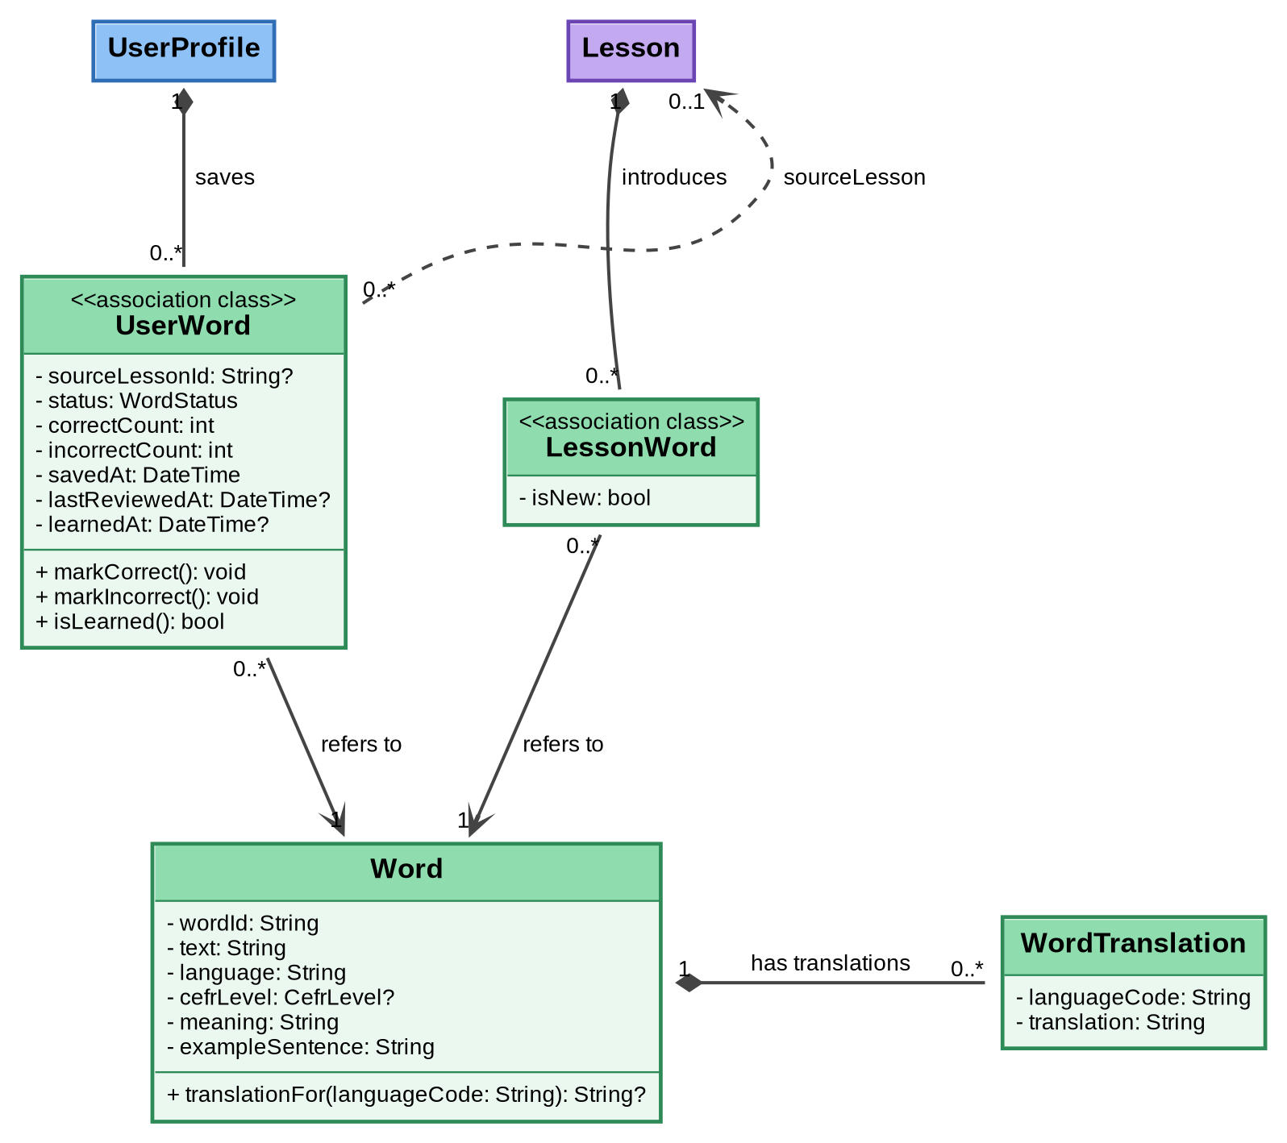
Figure 7: Class diagram – vocabulary module

5.2.4 Relationships
Class A | Relationship | Class B | Multiplicity (A : B) | Type | ER source
UserProfile | has | UserProgress | 1 : 1 | Composition | USER – USER_PROGRESS
UserProfile | takes | LevelAssessment | 1 : 0..* | Association | USER – LEVEL_ASSESSMENT
UserProfile | selects (interests) | Category | 0..* : 0..* | Association | USER – CATEGORY (USER_INTEREST)
Category | groups | Scenario | 0..1 : 0..* | Association | CATEGORY – SCENARIO
UserProfile | creates (custom) | Scenario | 0..1 : 0..* | Association | USER – SCENARIO
UserProfile | practices | Lesson | 1 : 0..* | Association | USER – LESSON
Scenario | used in | Lesson | 1 : 0..* | Association | SCENARIO – LESSON
Lesson | contains | Message | 1 : 1..* | Composition | LESSON – MESSAGE
Message | has | Correction | 1 : 0..* | Composition | MESSAGE – CORRECTION
Lesson | evaluated by | Evaluation | 1 : 0..1 | Composition | LESSON – EVALUATION
Lesson | introduces | Word (via LessonWord) | 1 : 0..* | Composition + reference | LESSON – WORD (LESSON_WORD)
UserProfile | saves | Word (via UserWord) | 1 : 0..* | Composition + reference | USER – WORD (USER_WORD)
Word | has translations | WordTranslation | 1 : 0..* | Composition | WORD – WORD_TRANSLATION
UserWord | sourceLesson | Lesson | 0..* : 0..1 | Dependency | USER_WORD.source_lesson_id
Note: the ER diagram shows the Lesson – Evaluation relationship as 1 : 1. In the class diagram it is 0..1 because an evaluation is created only when the lesson is completed (see the Lesson state diagram). Derived values that the schema deliberately does not store are provided as methods: Scenario.isCustom() (createdBy is not null) and Evaluation.overallScore() (average of the three scores).

5.3 Enumerations
The enumerations below define the allowed values of the status and type attributes. Their stored values in Firestore and Hive are the lowercase snake_case values defined in the schema (for example, in_progress, placement_test, auto_update); newWord is stored as new because new is a reserved word in Dart.
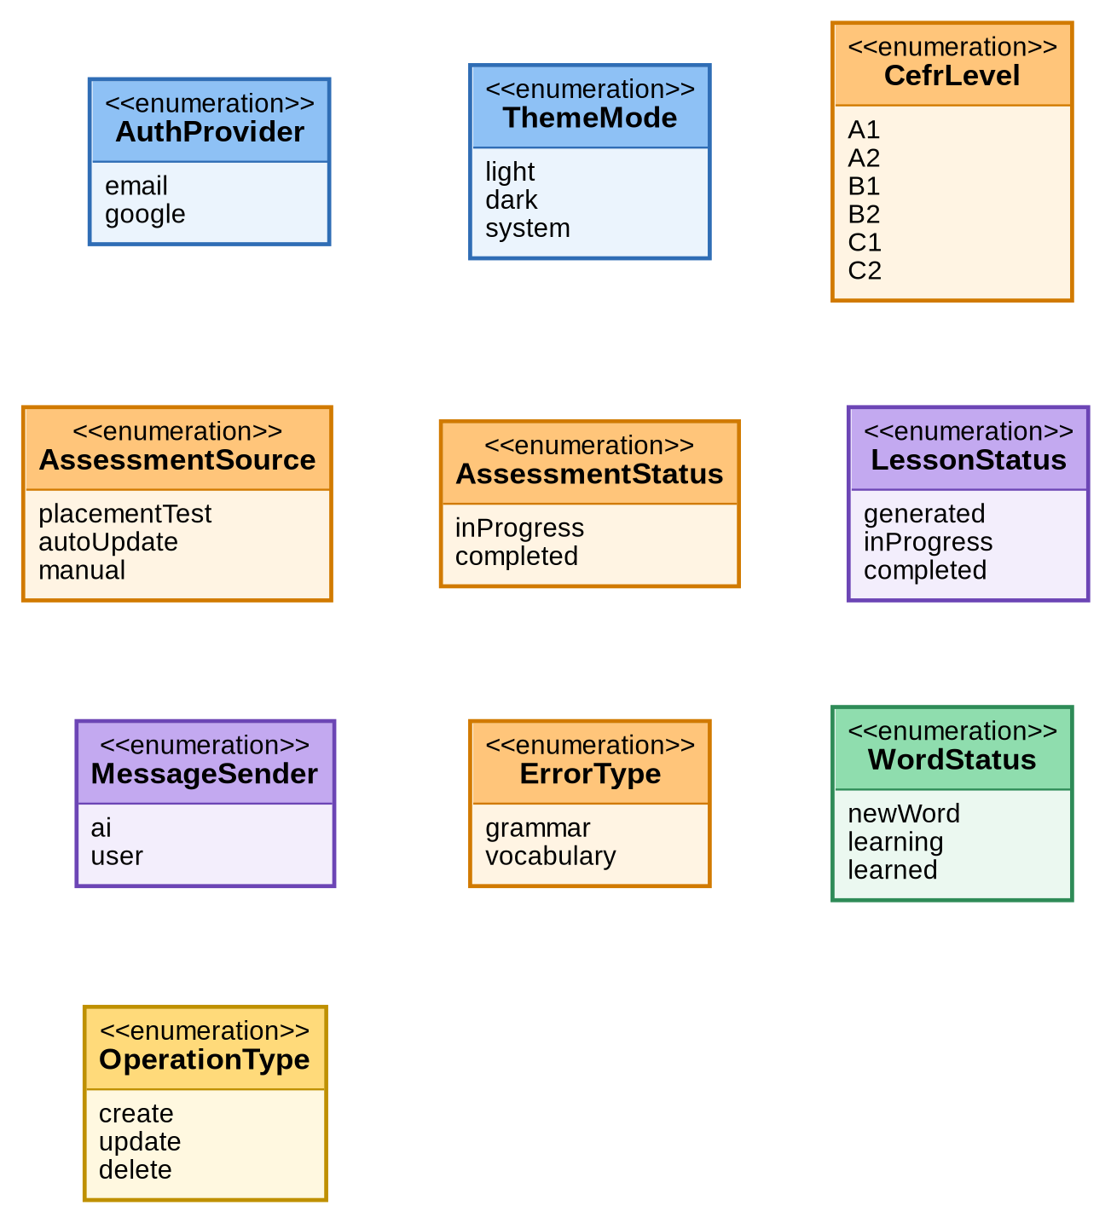
Figure 8: Enumerations used by the domain classes

5.4 Application Architecture (MVVM)
The figure below shows how the Model–View–ViewModel layers are realised as classes. Dependencies point in one direction only: a View observes one ViewModel, a ViewModel uses repositories, a repository uses services, and a service communicates with one external system or storage. Domain classes from Section 5.2 are the data passed between the layers.
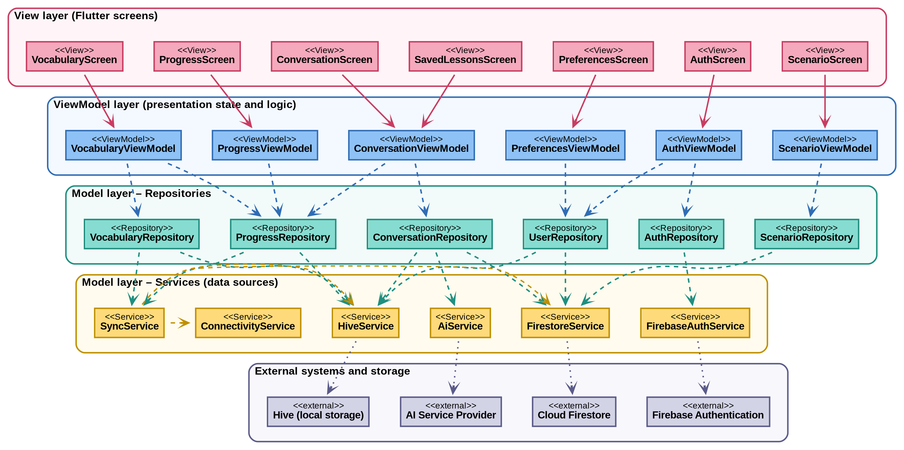
Figure 9: Class diagram – MVVM layers and dependencies

Dependency rules
- Views never call repositories or services; they display ViewModel state and forward user actions.
- ViewModels never access Firebase, Hive or the AI service directly; they call repositories only.
- Repositories decide whether data comes from Cloud Firestore, Hive or the AI service, and create a SyncOperation when cloud synchronization cannot be completed.
- Only the services know the external APIs, so a provider (for example the AI service) can be replaced without changing the layers above it.

5.5 View Layer
The View layer consists of the Flutter screens. Each screen is bound to one ViewModel and contains no business logic.
View (screen) | ViewModel | Use cases | Purpose
AuthScreen | AuthViewModel | UC-01 | Registration, login and logout
PreferencesScreen | PreferencesViewModel | UC-02 | Learning preferences, interests and English level
ScenarioScreen | ScenarioViewModel | UC-03 | Browse predefined scenarios or create a custom one
ConversationScreen | ConversationViewModel | UC-04, UC-05 | Generated conversation, practice, feedback
SavedLessonsScreen | ConversationViewModel | UC-08 | Open saved lessons without internet connection
VocabularyScreen | VocabularyViewModel | UC-06 | Saved words, review mode
ProgressScreen | ProgressViewModel | UC-07 | Completed lessons, learned words, level

5.6 ViewModel Layer
ViewModels hold the presentation state (data, loading flag, error message), validate user input, and call the repositories. They correspond to the processes P1–P6 of the Data Flow Diagram.
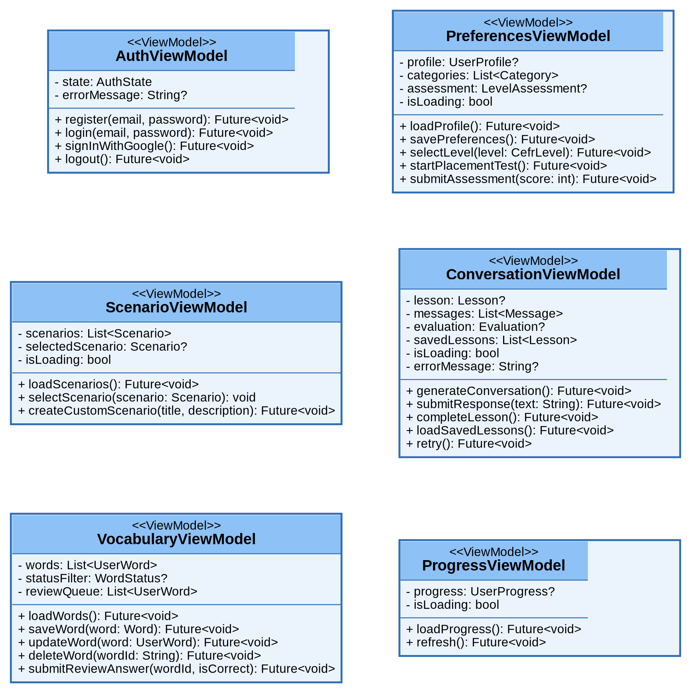
Figure 10: Class diagram – ViewModel layer
ViewModel | Responsibility | Repositories used
AuthViewModel | Registration, login, Google sign-in and logout; exposes the authentication state (P1). | AuthRepository, UserRepository
PreferencesViewModel | Loads and saves language settings, interests and level; runs the placement test (P2). | UserRepository
ScenarioViewModel | Lists predefined and custom scenarios and keeps the selected scenario (P3). | ScenarioRepository
ConversationViewModel | Generates the conversation, submits responses, shows feedback, completes the lesson and loads saved lessons (P3, P4). | ConversationRepository, ProgressRepository
VocabularyViewModel | Adds, edits, deletes and reviews words; updates the word status (P5). | VocabularyRepository, ProgressRepository
ProgressViewModel | Loads the progress summary for the dashboard (P6). | ProgressRepository

5.7 Repository Layer
Repositories hide where data is stored. They convert between domain classes and Firestore documents or Hive models, choose the data source, and pass requests that need AI to the AI service.
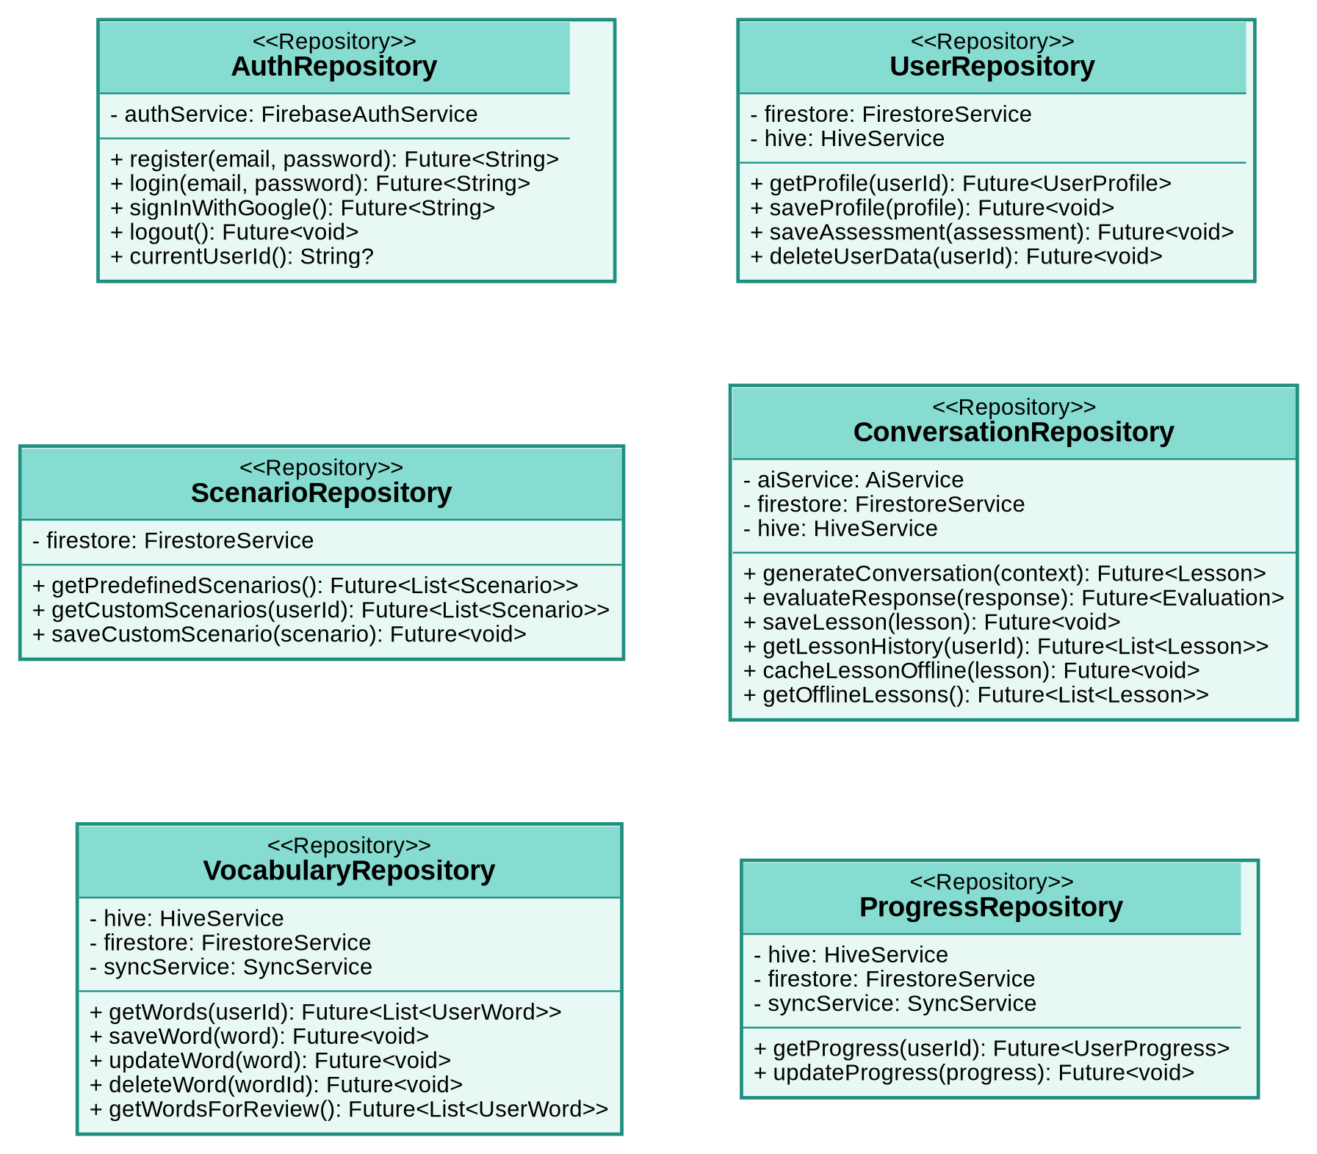
Figure 11: Class diagram – repository layer
Repository | Responsibility | Services used
AuthRepository | Authenticates the learner and returns the user id. | FirebaseAuthService
UserRepository | Stores the profile, interests and level assessments; deletes all user data when the account is deleted. | FirestoreService, HiveService
ScenarioRepository | Reads predefined scenarios and stores custom scenarios. | FirestoreService
ConversationRepository | Builds the prompt, requests generation and evaluation, saves lessons and messages, and caches lessons for offline use. | AiService, FirestoreService, HiveService
VocabularyRepository | Reads and writes saved words locally first and queues changes for cloud synchronization. | HiveService, FirestoreService, SyncService
ProgressRepository | Reads and updates the progress counters used by the dashboard. | HiveService, FirestoreService, SyncService

5.8 Service Layer
Services wrap the external systems. SyncService keeps a queue of SyncOperation objects (the Hive syncQueueBox) and uses ConnectivityService to know when synchronization can run.
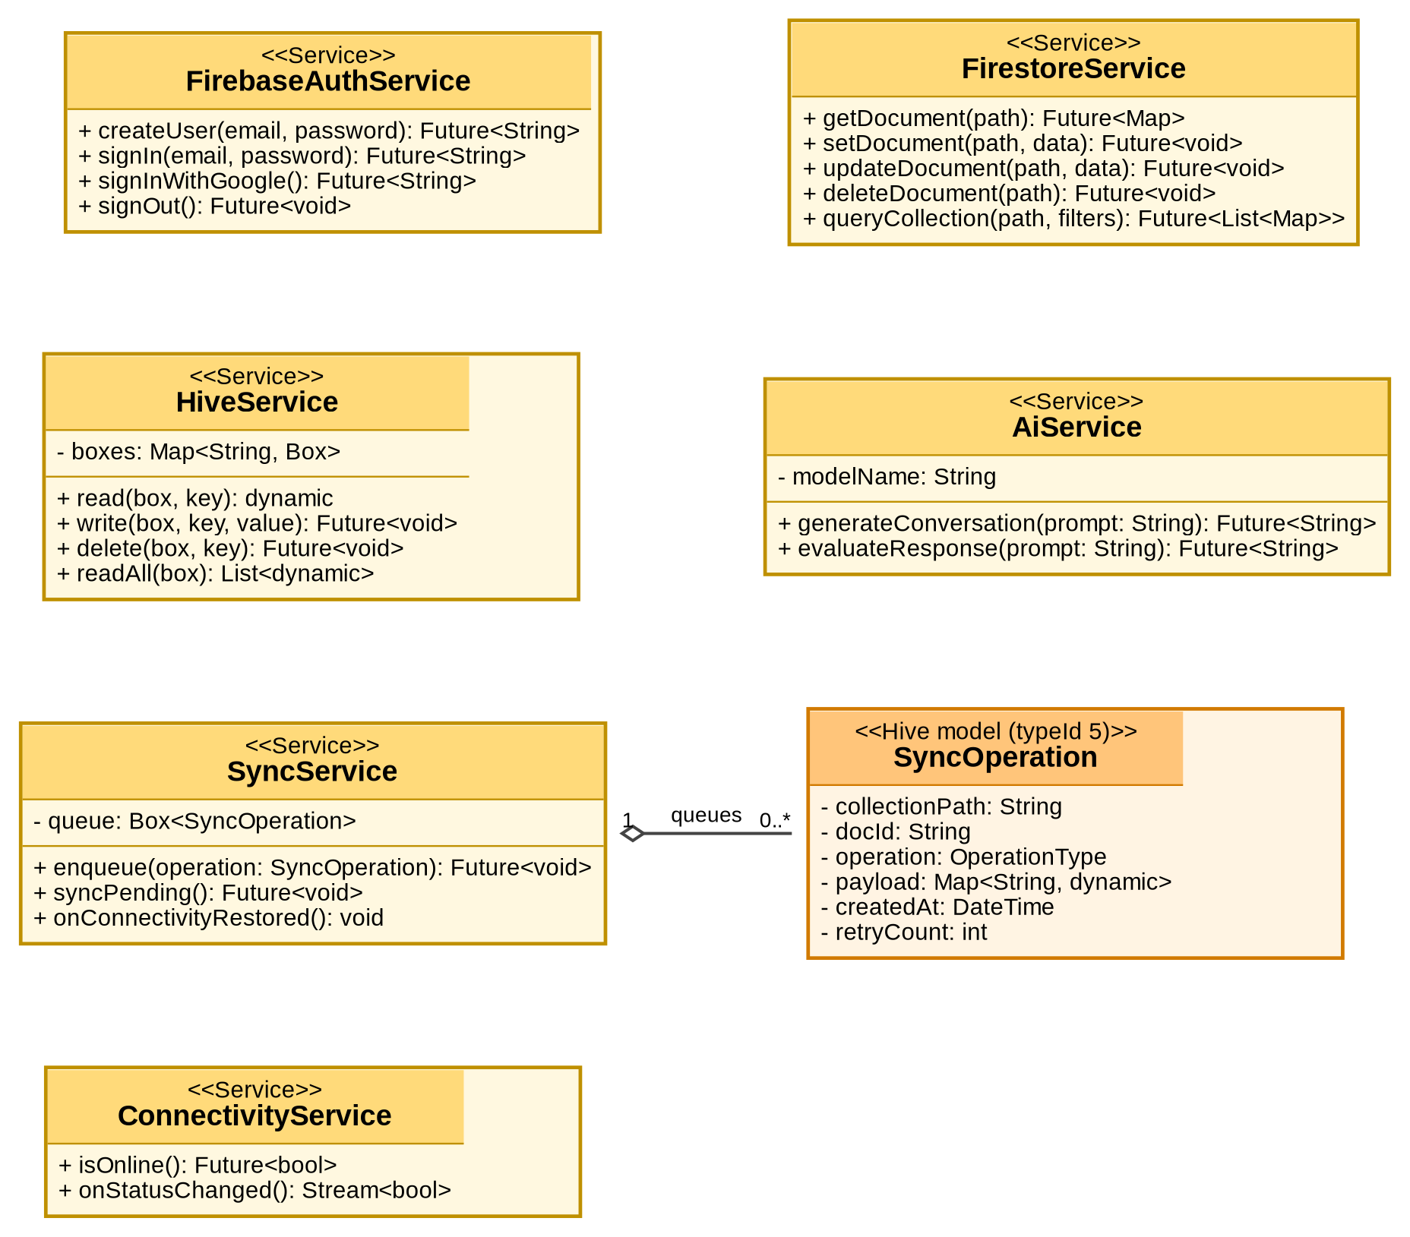
Figure 12: Class diagram – service layer
Service | Responsibility | External system / storage
FirebaseAuthService | Creates users, signs in (email/password, Google) and signs out. | Firebase Authentication
FirestoreService | Generic read, write, update, delete and query operations on documents. | Cloud Firestore
HiveService | Reads and writes the local boxes: vocabularyBox, offlineLessonsBox, progressBox, syncQueueBox, settingsBox. | Hive (local storage)
AiService | Sends prompts for conversation generation and evaluation; only the information needed is sent. | AI Service Provider
SyncService | Queues operations and synchronizes them when connectivity is restored. | Hive and Cloud Firestore (through their services)
ConnectivityService | Reports whether the device is online and notifies when the status changes. | Device network status

5.9 Traceability: Use Cases to Classes
The table links every use case to the classes that implement it, so that each requirement can be traced from the use case to the design.
Use case | View | ViewModel | Repository | Services
UC-01 Register / Login | AuthScreen | AuthViewModel | AuthRepository, UserRepository | FirebaseAuthService, FirestoreService
UC-02 Select English Level | PreferencesScreen | PreferencesViewModel | UserRepository | FirestoreService, HiveService
UC-03 Choose Conversation Scenario | ScenarioScreen | ScenarioViewModel | ScenarioRepository | FirestoreService
UC-04 Generate AI Conversation | ConversationScreen | ConversationViewModel | ConversationRepository | AiService, FirestoreService, HiveService
UC-05 Evaluate Performance and Receive Feedback | ConversationScreen | ConversationViewModel | ConversationRepository | AiService, FirestoreService
UC-06 Manage Vocabulary | VocabularyScreen | VocabularyViewModel | VocabularyRepository | HiveService, SyncService
UC-07 Track Learning Progress | ProgressScreen | ProgressViewModel | ProgressRepository | HiveService, FirestoreService
UC-08 Access Saved Lessons Offline | SavedLessonsScreen | ConversationViewModel | ConversationRepository | HiveService
UC-09 Store and Synchronize Learning Data | – | VocabularyViewModel, ProgressViewModel | VocabularyRepository, ProgressRepository | SyncService, ConnectivityService, FirestoreService, HiveService

